**TRAFFIC MANAGEMENT SYSTEM**

**PHASE 5: SUBMISSION DOCUMENT**

* **ABSTRACT:**

The project's goal is to implement an IoT-based traffic monitoring system with data analytics capabilities. This system aims to offer real-time traffic flow and congestion information to commuters through public platforms and mobile apps. By providing this data, the project intends to empower commuters to make informed decisions about their routes, ultimately contributing to the alleviation of traffic congestion. The project encompasses defining objectives, designing the IoT traffic monitoring system, developing the traffic information platform, and integrating them using IoT technology and Python.

* **PROJECT OBJECTIVES**:
* Real-time traffic monitoring.
* Congestion detection.
* Route optimization.
* Improved computing experience.

* **REAL-TIME TRAFFIC MONITORING:**

For real-time traffic monitoring, consider using navigation apps like Google Maps or Waze, which provide live traffic updates based on user data and official sources. Additionally, traffic management authorities in some cities offer online platforms or apps with real-time traffic information.

* **CONGESTION DETECTION**:

Detecting congestion typically involves analyzing traffic flow data. This can be done using various methods, such as monitoring vehicle speeds, traffic volume, and occupancy rates on roads. Advanced technologies like sensors, cameras, and machine learning algorithms are often employed for accurate congestion detection.

* **ROUTE OPTIMIZATION:**

Route optimization involves finding the most efficient path between two or more locations. This can be achieved through algorithms that consider factors likedistance, traffic conditions, and travel time. Advanced route optimization often integrates real-time data and machine learning to adapt to changing conditions**,** providing users with the most time-effective and convenient routes.

* **IMPROVED COMPUTING EXPERIENCE:**

An improved computing experience can be achieved through faster hardware, optimized software, and seamless integration of applications. Utilizing advanced processors, sufficient RAM, and high-speed storage contributes to faster performance. Additionally, user-friendly interfaces, responsive design, and efficient algorithms enhance the overall experience. Regular software updates, cybersecurity measures, and personalized customization options further contribute to an improved computing experience**.**

* **IOT SENSOR SETUP:**
* Plan the deployment of IoT devices for traffic monitoring**:**

**1. *Identify Key Locations:\***

- Determine critical points like intersections, highways, or busy streets where sensors can provide valuable data on traffic flow and congestion.

**2. *Sensor Selection:\***

- Choose appropriate sensors (e.g., cameras, radar, lidar) based on the specific needs of each location. Consider factors like accuracy, cost, and power consumption.

**3. *Connectivity:\***

- Ensure robust connectivity for the sensors, such as cellular, Wi-Fi, or a Integration Approach

**4. *Power Supply:\***

- Plan for power sources, considering both wired (electric grid) and wireless options (e.g., solar or battery). Optimize power consumptio

**5.*Data Security:\***

- Implement strong 5security measures to protect data transmission and storage, including encryption and secure communication protocols.

* **Real-Time Transit Information Platform:**
* To design a web-based platform and mobile apps for real-time traffic information, you'll need a comprehensive system. Here's a simplified outline:

**\*1. System Architecture:\***

- Utilize a cloud-based infrastructure for scalability and reliability.

- Set up data processing modules to handle real-time traffic data.

**\*2. Data Sources:\***

- Integrate with traffic monitoring systems, GPS data, and other relevant sources.

- Collaborate with local traffic authorities for accurate and up-to-date information.

**\*3. Backend Development:\***

- Develop APIs to fetch and update traffic data.

- Implement a real-time database to store and retrieve information efficiently.

**\*4. Frontend Development:\***

- Create a user-friendly web interface and mobile app with maps and intuitive design.

**5. Real-time Updates:\***

- Implement a WebSocket or similar technology for instant updates.

- Notify users about traffic incidents, road closures, or alternate routes.

* **Integration Approach:**
* To streamlined design outline for a web-based platform and mobile apps for real-time traffic information:

**\*1. Platform Overview:\***

- *Name:* TrafficNow

- *Objective:* Provide real-time traffic information to the public for informed travel decisions.

**\*2. Architecture:\***

- *Backend:* Cloud-based infrastructure using serverless architecture for scalability.

- *Data Sources:* Integrate with traffic APIs, GPS data, and official traffic feeds.

- *Database:* Real-time database for efficient data storage and retrieval.

**\*3. User Interface:\***

- *Web Interface:*

- Clean and intuitive design with a map displaying real-time traffic conditions.

- User-friendly filters for different layers (e.g., incidents, congestion).

- Search functionality for specific routes.

* **ALGORITHM:**

STEP-1. *Data Collection:*

- Utilize IoT devices such as traffic cameras, sensors, and GPS trackers to collect real-time data on traffic conditions.

STEP-2. *Data Preprocessing:*

- Clean and preprocess raw data to handle missing values and ensure data consistency.

STEP-3. *Traffic Flow Prediction:*

- Apply machine learning algorithms like recurrent neural networks (RNNs) or Long Short-Term Memory (LSTM) networks to predict traffic flow patterns based on historical data.

STEP-4. *Congestion Detection:*

- Develop algorithms that detect congestion by analyzing factorssuch as traffic speed, density, and historical patterns. Machine learning classifiers or rule-based systems can be effective.

STEP-5. *Dynamic Routing Optimization:*

- Implement algorithms that dynamically suggest optimal routes based on real-time traffic updates. Consider Dijkstra's algorithm or A* algorithm for efficient pathfinding.

STEP-6. *User-Friendly Interface:*

- Design a user-friendly interface for the public platform or mobile apps, providing intuitive access to real-time traffic information and route recommendations.

STEP-7. *Notification System:*

- Integrate a notification system to alert commuters about potential congestion, accidents, or alternative routes.

STEP-8. *Machine Learning for Adaptation:*

- Use reinforcement learning to enable the system to adapt and improve route recommendations based on user feedback and changing traffic patterns.

STEP-9. *Integration with Mapping Services:*

- Integrate with popular mapping services to leverage existing geographical data and enhance accuracy in route recommendations.

STEP-10. *Scalability and Cloud Integration:*

- Ensure the system's scalability by leveraging cloud services for data storage, processing, and hosting of the public platform or mobile apps.

STEP-11. *Privacy Considerations:*

- Implement robust privacy measures to safeguard user data collected through IoT devices, adhering to relevant regulations.

* **PROGRAM:**

**class TrafficLight:**

**def __init__(self):**

**self.state = 'red'**

**def change_state(self, new_state):**

**self.state = new_state**

**print(f"Traffic Light: {self.state}")**

**class TrafficController:**

**def __init__(self):**

**self.traffic_light = TrafficLight()**

**def manage_traffic(self):**

**while True:**

**self.traffic_light.change_state('red')**

**time.sleep(5)**

**self.traffic_light.change_state('green')**

**time.sleep(5)**

**self.traffic_light.change_state('yellow')**

**time.sleep(2)**

**def main():**

**controller = TrafficController()**

**controller.manage_traffic()**

**if __name__ == "__main__":**

**main()**

* **SENSOR:**
* An IoT-based traffic monitoring system using sensors can provide real-time traffic data by deploying various sensors at key locations, such as roads, intersections, and highways. These sensors can capture a range of data to help monitor and manage traffic effectively:

1. Vehicle Detection Sensors: Inductive loop sensors, ultrasonic sensors, or video cameras can be used to detect vehicles' presence, count them, and classify them by type (e.g., car, truck).

2. Traffic Flow Sensors: These sensors monitor the speed and flow of traffic, helping to detect congestion and bottlenecks.

3. Environmental Sensors: Environmental factors like weather and air quality can impact traffic conditions. Sensors measuring these variables can provide additional context.

4. GPS and Smartphone Data: Integrating data from GPS devices and smartphones can provide real-time location information for vehicles, aiding in traffic analysis.

5. Smart Traffic Signals: Coordinating traffic signals based on real-time data can help optimize traffic flow.

6. Data Processing and Analysis: The collected data is sent to a central system for processing and analysis. Machine learning algorithms can predict traffic patterns and suggest optimal routes.

7. Real-time Feedback: Users can access real-time traffic data through apps or websites, which may offer route suggestions and traffic alerts.

8. Traffic Management: Traffic authorities can use the data to manage traffic, reroute vehicles, and respond to incidents promptly.

9. Historical Data: Storing historical data allows for long-term traffic analysis and infrastructure planning.

10. Communication Infrastructure: A robust communication network (e.g., 4G, 5G, or dedicated IoT networks) is essential for data transmission.

This system can enhance traffic management, reduce congestion, and improve overall road safety by providing real-time traffic data to both authorities and drivers.

* **PROTOCOL:**
* IoT-based traffic monitoring systems that provide real-time traffic data typically rely on specific communication protocols to enable seamless data exchange between sensors, devices, and a central control system. Some commonly used protocols in such systems include:

1. MQTT (Message Queuing Telemetry Transport): MQTT is a lightweight, publish-subscribe messaging protocol ideal for IoT applications. It allows sensors to publish data to a broker, which can then distribute the data to subscribers, including the central traffic management system.

2. HTTP/HTTPS (Hypertext Transfer Protocol): Web-based protocols like HTTP and its secure version, HTTPS, can be used to transmit real-time traffic data over the internet. IoT devices can send HTTP requests to a server or API to share data.

3. CoAP (Constrained Application Protocol): CoAP is designed for constrained devices and networks. It's suited for IoT traffic monitoring systems where resource-constrained sensors need to communicate with the central server efficiently.

4. AMQP (Advanced Message Queuing Protocol): AMQP is a message-oriented protocol that supports real-time data exchange and queuing, making it useful for handling large volumes of traffic data efficiently.

5. LoRaWAN (Long Range Wide Area Network): LoRaWAN is suitable for long-range, low-power IoT sensors. It's often used for applications like tracking vehicles and monitoring traffic conditions in smart cities.

6. Sigfox: Sigfox is a low-power wide-area network (LPWAN) technology that can transmit small amounts of data over long distances. It's suitable for simple, battery-operated traffic sensors.

7. WebSocket: WebSocket is a protocol that enables real-time, full-duplex communication over a single, long-lived connection. It's useful for streaming real-time traffic data to web applications.

8. OCPP (Open Charge Point Protocol): OCPP is specific to electric vehicle charging stations and can be used in traffic monitoring systems that focus on managing EV charging infrastructure.

9. SNMP (Simple Network Management Protocol): SNMP can be used for monitoring and managing network-connected traffic sensors and devices in a centralized manner.

The choice of protocol depends on factors such as the nature of the sensors, the communication network, data volume, and the specific requirements of the traffic monitoring system. Combining different protocols within the system may also be necessary to handle various types of data and devices effectively.

* **COMMUNICATION**:
* An IoT-based traffic monitoring system that provides real-time traffic data relies on effective communication among various components, including sensors, devices, and the central control system. Here's how communication is established within such a system:

**1. *Sensor Communication*:** IoT sensors are deployed at key locations to monitor traffic conditions. These sensors use various communication methods, including wired (Ethernet) or wireless (Wi-Fi, cellular, LoRaWAN) to transmit data to a central point.

**2. *Data Collection and Aggregation*:** The central control system collects data from multiple sensors. It communicates with sensors through their respective communication protocols, such as MQTT or CoAP for lightweight IoT communication.

**3. *Sensor Data Transmission*:** Sensors transmit real-time traffic data over the selected communication network to ensure data reaches the central control system promptly.

**4. *Data Processing and Analysis*:** The central system processes and analyzes the incoming traffic data to derive insights, detect congestion, and generate real-time traffic reports.

**5. *Traffic Management Communication*:** Traffic management decisions, such as adjusting traffic signal timings or providing alerts to commuters, are communicated back to the field through the same communication network, allowing for dynamic traffic control.

**6. *User-Facing Communication*:** Real-time traffic data is often made accessible to users through various communication channels, including mobile apps, websites, and traffic signs. Users can access up-to-date information regarding traffic conditions.

**7. *Historical Data Storage*:** Communication is also used to transmit and store historical traffic data for long-term analysis and infrastructure planning.

**8. *Security and Encryption*:** To protect the data transmitted and maintain the integrity of the system, security measures like encryption and secure communication protocols (e.g., HTTPS) are applied.

Effective communication is essential to ensure that real-time traffic data is collected, processed, and disseminated efficiently, ultimately leading to improved traffic management and a better commuting experience.

**COMPONENTS OF TRAFFIC MONITORING SYSTEM:**

**\*Sensors:\***

- Cameras for video surveillance.

- Inductive loop detectors embedded in road surfaces.

- Radar or lidar sensors for speed detection.

**\*Communication Infrastructure:\***

- Network connectivity for data transmission.

- Wireless or wired communication systems.

**\*Data Processing Units:\***

- Computers or servers to process and analyze collected data.

- Algorithms for traffic pattern recognition and analysis.

**\*Central Control System:\***

- Centralized software for managing and coordinating traffic data.

- User interface for monitoring and control.

**\*Database:\***

- Storage for historical and real-time traffic data.

- Enables trend analysis and reporting.

**\*Traffic Management Software:\***

- Applications for controlling traffic signals and managing congestion.

- Integration with other intelligent transportation systems.

**\*Power Supply:\***

- Reliable power sources for continuous operation.

**\*User Interface:\***

- Display systems for operators to visualize data.

- Control interfaces for manual intervention if needed.

**\*Algorithms and Analytics:\***

- Intelligent algorithms for traffic prediction, optimization, and anomaly detection.

**\*Integration with Other Systems:\***

- Coordination with emergency services, public transportation, or smart city infrastructure.

**\*Maintenance and Diagnostics:\***

- Systems for monitoring the health of components and predicting maintenance needs.

**SENSORS USED:**

**\*Inductive Loop Sensors:\***

**DEFINITION:**

* Buried in the road, these detect the presence of vehicles by changes in inductance.



* An inductive loop sensor is a type of sensor commonly used in traffic management and vehicle detection systems.
* It typically consists of a wire loop embedded in the pavement, forming a coil.
* When a conductive object such as a vehicle passes over the loop, it disrupts the magnetic field, allowing the sensor to detect the presence or passage of the vehicle.
* Inductive loop sensors are widely used in traffic management and control systems. Some of their key applications include:
* **Vehicle detection:**

Inductive loop sensors can detect the presence and movement of vehicles, allowing for the implementation of traffic light control systems and automatic toll collection systems.

* **Traffic monitoring:**

These sensors can provide real-time data on traffic flow, enabling authorities to monitor and manage traffic conditions, optimize signal timings, and improve overall traffic management strategies.

* **Vehicle counting:**

Inductive loop sensors are often used to count the number of vehicles passing through specific points, aiding in the analysis of traffic patterns and trends for planning and decision-making purposes.

* **Incident detection**:

By sensing disruptions in the normal traffic flow, inductive loop sensors can help in detecting accidents or other incidents, allowing for a quicker response from emergency services and traffic management authorities.

**PIN CONFIGURATION:**

*Loop Input/Output:*

- Pin 1: Loop Output (Connects to the traffic signal controller or processing unit)

- Pin 2: Ground (GND)

- Pin 3: Loop Input (Connects to the loop coil)

**\*Video Cameras:\***

DEFINITION:

* Capture real-time footage for visual monitoring and analysis.

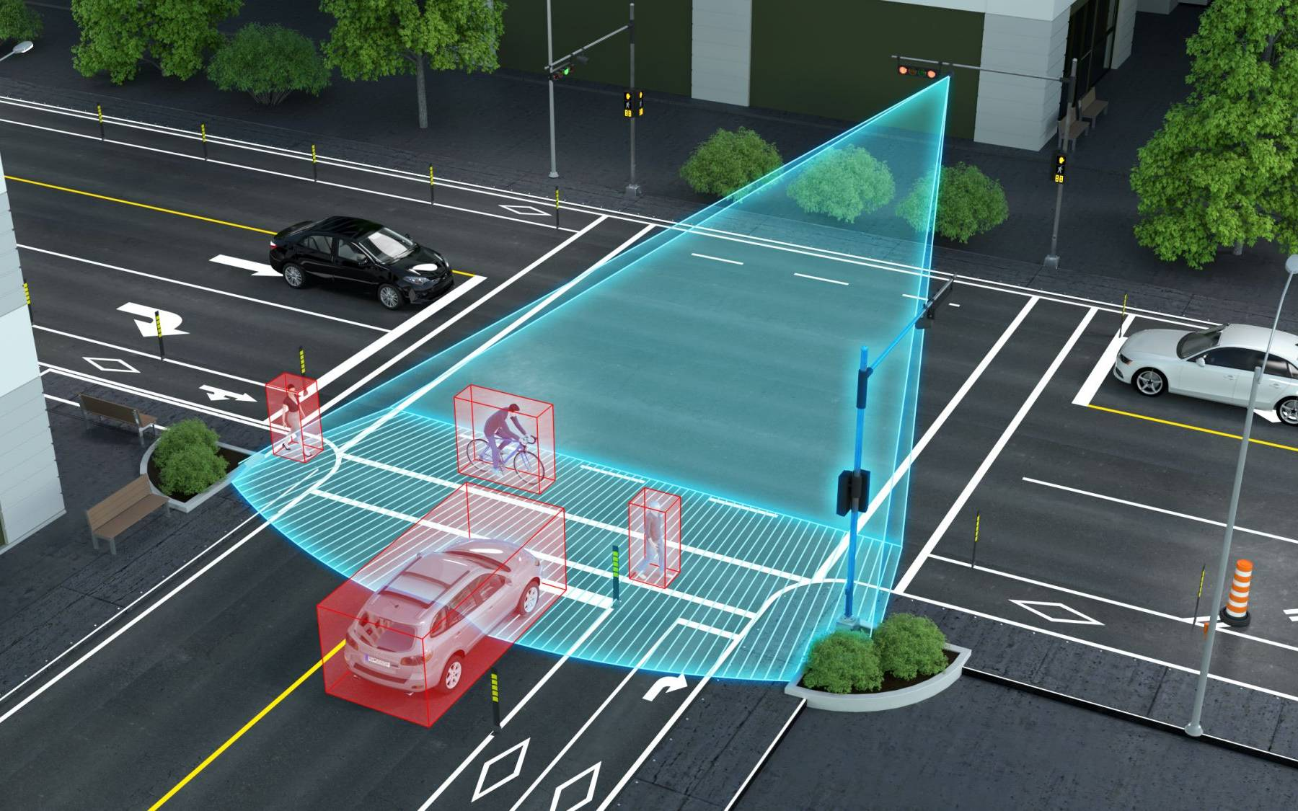

* A video camera traffic monitoring system typically uses a network of cameras to capture and monitor traffic patterns, violations, and incidents on roadways.
* These systems often employ advanced image processing techniques, including object recognition and tracking, to detect and analyze various parameters such as
* vehicle speed,
* traffic density
* compliance with traffic rules.

PIN CONFIGURATION:

1. *Power and Ground:*

- Pin 1: Power (Vcc)

- Pin 2: Ground (GND)

2. *Video Output:*

- Pin 3: Video Output (analog or digital signal)

3. *Audio (if applicable):*

- Pin 4: Audio Output (for cameras with built-in microphones)

4. *Data Communication (for IP Cameras):*

- Pin 5: Data+ (for data communication in IP cameras)

- Pin 6: Data- (for data communication in IP cameras)

5. *Control (if applicable):*

- Pin 7: Control signals (e.g., PTZ - Pan, Tilt, Zoom control)

**\*Radar Sensors:\***

DEFINITION:

* Use radio waves to detect the speed and presence of vehicles.

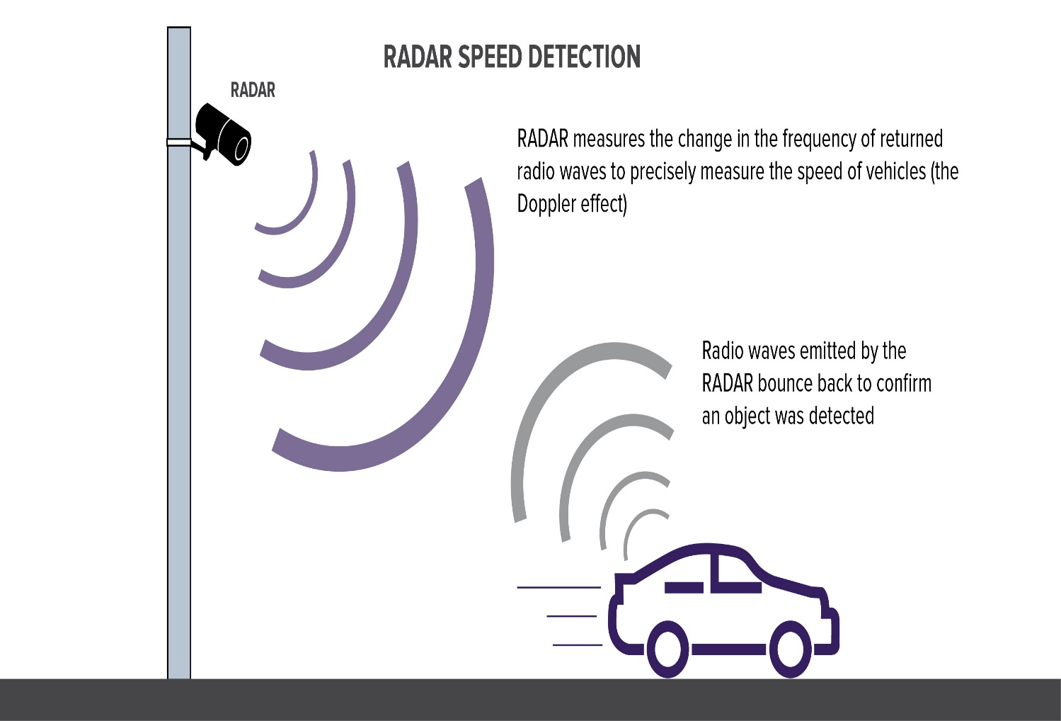

* A radar sensor traffic monitoring system typically employs radar technology to detect and monitor the flow of traffic on roads or highways.
* These systems use radar waves to measure the speed, volume, and movement of vehicles, providing valuable data for traffic management and control.

PIN CONFIGURATION:

1. *Power Supply:*

- Pin 1: Power (Vcc)

- Pin 2: Ground (GND)

2. *Signal Output:*

- Pin 3: Signal Output (providing information about detected objects, speed, or distance)

3. *Control/Input (optional):*

- Pin 4: Control/Input (for configuration or triggering specific functionalities)

4. *Communication (for networked or advanced radar systems):*

- Pin 5: Communication (TX/RX for data exchange in networked systems)

5. *Antenna Connections (for radar modules with separate antennas):*

- Pin 6: Antenna Connection 1

- Pin 7: Antenna Connection 2

**\*LiDAR (Light Detection and Ranging):\***

**DEFINITION:**

* Similar to radar but uses laser light to measure distances and create detailed maps.

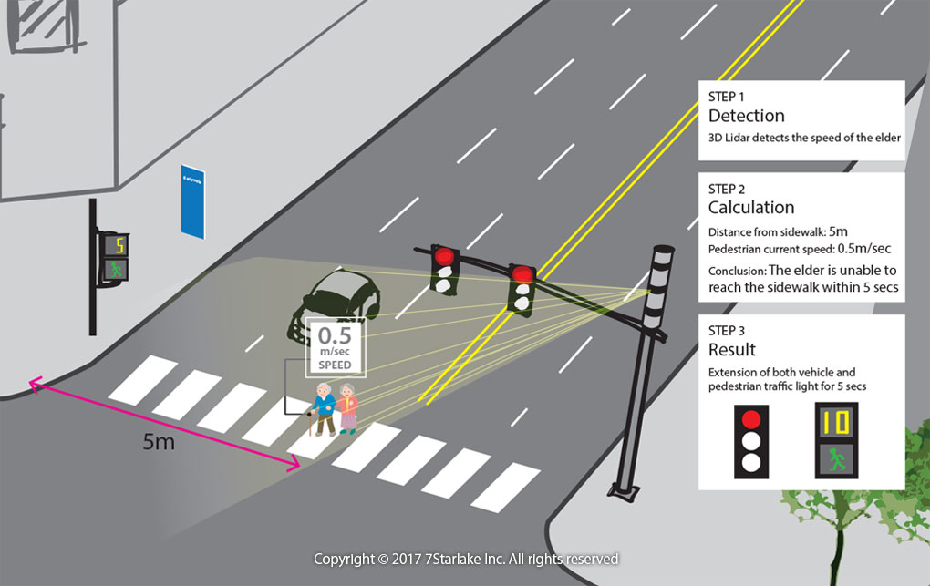

* A LiDAR (Light Detection and Ranging) traffic monitoring system utilizes laser-based technology to measure the distance to an object or surface.
* It can be employed for various applications, including traffic m It operates by sending out laser pulses and measuring the time it takes for the light to reflect off objects and return to the sensor.
* By analyzing the properties of the reflected light, such as intensity and wavelength, LiDAR systems can create precise three-dimensional representations of objects and environments.
* This technology is widely used in various fields, including geography, geology, seismology, archaeology, forestry, atmospheric physics, and autonomous vehicle **navigation.onitoring**, speed detection, and vehicle counting.

PIN CONFIGURATION:

1. *Power Supply:*

- Pin 1: Power (Vcc)

- Pin 2: Ground (GND)

2. *Data Interface:*

- Pin 3: Data Output (providing information about the LiDAR measurements)

3. *Communication (optional):*

- Pin 4: Communication (TX/RX for data exchange in networked systems)

4. *Control/Input (optional):*

- Pin 5: Control/Input (for configuration or triggering specific functionalities)

5. *Enable/Disable (optional):*

- Pin 6: Enable/Disable (for turning the LiDAR on or off)

6. *Serial Communication (for LiDARs with UART or other serial interfaces):*

- Pin 7: RX (Receive)

- Pin 8: TX (Transmit)

**\*GPS (Global Positioning System):\***

DEFINITION:

* Tracks the movement of vehicles for traffic flow analysis.

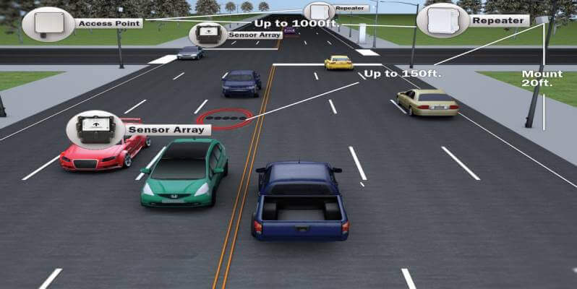

* GPS (Global Positioning System) is commonly utilized in traffic monitoring systems to track and manage the flow of traffic. By using GPS, these systems can gather real-time data on vehicle locations, speeds, and movements, allowing for the efficient monitoring of traffic patterns and the identification of congestion points.
* The GPS receiver measures the time it takes for the signals to travel from the satellites to the receiver.
* By using the difference in time and the known positions of the satellites, the receiver can determine its own distance from each satellite.
* Once the receiver has obtained signals from at least four satellites, it can accurately calculate its three-dimensional position (latitude, longitude, and altitude), as well as its precise time.
* This information can be used for various navigation, mapping, surveying, and timing applications.

PIN CONFIGURATION:

1. *Power Supply:*

- Pin 1: Vcc (Power)

- Pin 2: Ground (GND)

2. *Communication (UART or Serial):*

- Pin 3: TX (Transmit from GPS to the microcontroller)

- Pin 4: RX (Receive into GPS from the microcontroller)

3. *Antenna Connection:*

- Pin 5: Antenna (for GPS signal reception)

4. *Data Output (optional):*

- Pin 6: PPS (Pulse Per Second, optional; used for precise timing applications)

5. *Backup Battery (optional):*

- Pin 7: Backup Battery (some GPS modules have a pin for an optional backup battery to retain data when main power is off)

**\*Microwave Sensors:\***

**DEFINITION:**

* Detects vehicles by emitting microwaves and measuring the reflection.

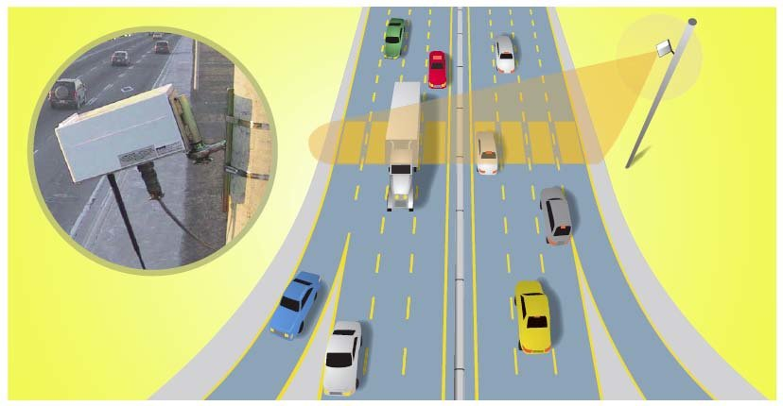

* Microwave sensors are commonly used in traffic monitoring systems for their ability to detect vehicles and measure traffic flow. These sensors work by emitting microwave signals and then analyzing the signals that bounce back after hitting objects, such as vehicles.
* Its primary purpose is to provide real-time or historical data on traffic conditions, including traffic flow, congestion, average speeds, and other relevant parameters, to facilitate efficient transportation management and planning.

PIN CONFIGURATION:

1. *Power Supply:*

- Pin 1: Vcc (Power)

- Pin 2: Ground (GND)

2. *Signal Output:*

- Pin 3: Signal Output (providing information about detected motion)

3. *Control/Input (optional):*

- Pin 4: Control/Input (for configuration or triggering specific functionalities)

4. *Enable/Disable (optional):*

- Pin 5: Enable/Disable (for turning the microwave sensor on or off)

5. *Communication (optional):*

- Pin 6: Communication (TX/RX for data exchange in networked systems)

**\*Acoustic Sensors:\***

* Analyze traffic by detecting sound pattern.

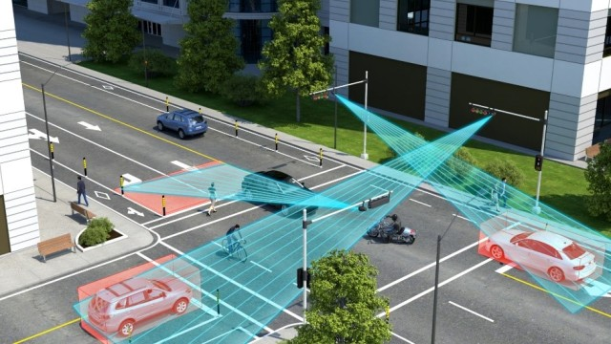

* An acoustic sensor in a traffic monitoring system can detect and analyze sounds associated with traffic, such as vehicle movements, honking, or sirens.
* This technology can contribute to traffic management by providing real-time data on traffic flow, identifying congestion, and even detecting unusual events like accidents.
* They are used in various applications, including:
* **Audio recording and surveillance:**

Acoustic sensors can capture and record sound for various purposes, such as security, monitoring, or research.

* **Vibration analysis:**

These sensors can be used to monitor and analyze the vibrations of machinery or structures, helping to identify potential faults, defects, or performance issues.

* **Environmental monitoring:**

Acoustic sensors can be employed to measure and analyze noise levels in the environment, contributing to efforts to control and reduce noise pollution.

* **Seismic activity detection:**

Acoustic sensors play a crucial role in detecting and analyzing seismic waves and other ground movements, contributing to earthquake monitoring and early warning systems.

PIN CONFIGURATION:

1. *Power Supply:*

- Pin 1: Vcc (Power)

- Pin 2: Ground (GND)

2. *Signal Output:*

- Pin 3: Signal Output (providing the analog audio signal)

3. *Shield (optional):*

- Pin 4: Shield or Ground (some microphones may have an additional pin for grounding purposes)

**\*Infrared Sensors:\***

**DEFINITION:**

* Measure heat emitted by vehicles to identify their presence.

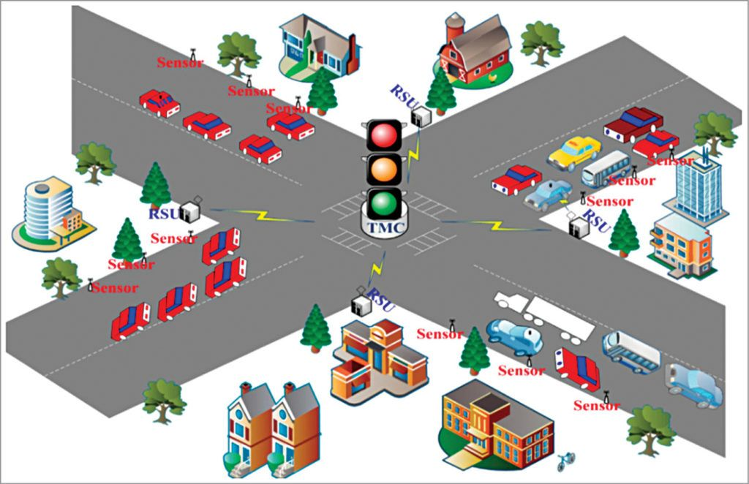

* Infrared sensors play a crucial role in traffic monitoring systems by detecting heat emitted by objects.

PIN CONFIGURATION:

1. *Power Supply:*

- Pin 1: Vcc (Power)

- Pin 2: Ground (GND)

2. *Signal Output:*

- Pin 3: Signal Output (providing information about detected infrared radiation)

3. *Control/Input (optional):*

- Pin 4: Control/Input (for configuration or triggering specific functionalities)

4. *Enable/Disable (optional): - Pin 5: Enable/Disable (for turning the infrared sensor on or off) - Pin 1: Power (Vcc)

- Pin 2: Ground (GND)

- Pin 3: Signal Output (connects to microcontroller)

**PROCEDURE:**

1. Data Collection:

a. Use Sensors: - Connect and configure your sensors (e.g., cameras, infrared sensors, radar).

- Use libraries or APIs provided by the sensor manufacturers to capture data.

b. Use APIs for Traffic Data: - Explore APIs provided by traffic data providers (e.g., Google Maps API, HERE API) to fetch real-time traffic conditions.

2. Data Processing: a. Preprocess Sensor Data:

- Clean and preprocess raw sensor data.

- Extract relevant features like vehicle count, speed, and congestion level.

b. Integrate External Data:

- Combine sensor data with data from external APIs for a comprehensive view.

c. Implement Machine Learning (Optional):

- Apply machine learning models for predictive analysis or anomaly detection if needed.

3. Traffic Analysis: a. Real-Time Analysis:

- Analyze the data in real-time to identify traffic patterns and congestion.

b. Generate Insights:

- Use statistical methods or machine learning algorithms to generate insights from the data.

4. Visualization:a. Use Plotting Libraries:

- Use Python plotting libraries (e.g., Matplotlib, Seaborn) to create visualizations.

- Plot graphs, charts, or maps to represent traffic flow and congestion

b. Dashboard Development (Optional):

- Develop a web-based dashboard using frameworks like Flask or Django.

- Display real-time traffic information and historical trends.

5. Alerts and Notifications (Optional):a. Set Thresholds:

- Define thresholds for congestion or unusual events.

b. Alert Mechanism:

- Implement an alert system to notify relevant authorities or users when thresholds are exceeded.

6. Deployment:a. Cloud Deployment:

- Host your system on cloud platforms like AWS, Azure, or Google Cloud for scalability.

b. Continuous Monitoring:

- Implement continuous monitoring for system health and data accuracy.

7. Documentation:

a. Code Documentation:

- Document your code for future reference.

**ALGORITHM:**

STEP-1:Building a traffic monitoring system involves various algorithms for data processing, analysis, and visualization.

STEP-2: Below is a simplified example algorithm in Python. This example assumes you have collected data from sensors and want to analyze and visualize traffic patterns.

STEP-3:This is a simple example, and your specific use case might require more advanced algorithms, such as machine learning for predictive analysis or anomaly detection.

STEP-4: Additionally, you may want to integrate data from external sources, implement alert mechanisms, or build a web-based dashboard for visualization.

STEP-5:Feel free to adapt the provided example based on your specific requirements and the structure of your data. If you have more specific needs or questions, please provide additional details for a more tailored solution.

**PROGRAM:**

while True:

# Collect traffic data here

traffic_data = {

"speed": random.randint(0, 100),

"congestion": random.uniform(0, 1),

"latitude": 123.456, # Replace with actual GPS data

"longitude": 789.012, # Replace with actual GPS data

# Add more data as needed

}

headers = {

"Authorization": f"Bearer {api_key}",

"Content-Type": "application/json"

}

response = requests.post(api_endpoint, json=traffic_data, headers=headers)

if response.status_code == 200:

print("Data sent successfully.")

else:

print(f"Failed to send data. Status Code: {response.status_code}")

time.sleep(60) # Adjust the interval as needed

**OUTPUT:**

while True:

# Collect traffic data here

traffic_data = {

"speed": random.randint(0, 100),

"congestion": random.uniform(0, 1),

"latitude": 123.456, # Replace with actual GPS data

"longitude": 789.012, # Replace with actual GPS data

# Add more data as needed

}

headers = {

"Authorization": f"Bearer {api_key}",

"Content-Type": "application/json"

}

response = requests.post(api_endpoint, json=traffic_data, headers=headers)

if response.status_code == 200:

print("Data sent successfully.")

else:

print(f"Failed to send data. Status Code: {response.status_code}")

time.sleep(60) # Adjust the interval as needed

To develop the web and android application for displays the displays real-time restroom availability and cleanliness data.

**WEB DEVELOPMENT USING HTML CODE:**

**HTML CODE:**

<!DOCTYPE *html*>

<html>

<head>

        <title>traffic monitering system</title>

  <link *rel*="stylesheet" *href*="style.css">

</head>

<body>

    <h1><font *color*="blue"><center><a *href*=></a>TRAFFIC MONITERING SYSTEM</a></center></font></h1>

    <center><img *src*="https://urbanupdate.in/wp-content/uploads/2019/07/E5ccmfalj3QPUk-TBkulPkzn2ztS8lOqJZGHlf_oBQ8-1280x960.jpg"*width*="600"*height*="400"></center>

  <script *src*="script.js"></script>

</body>

</html>

<!DOCTYPE *html*>

<html>

<head>

<title>Page Title</title>

</head>

<body>

<h1>Need of traffic monitering system</h1>

<P>traffic monitering refers to the use of technology to improve the management and efficiency of parking spaces. This can include features like sensors to detect available parking spots, mobile apps to help users find parking, and data analytics to optimize parking operations. It can reduce congestion, save time for drivers, and improve the utilization of parking facilities</P>

<center><h2><font *color*="green">OUR TEAM MEMBERS ARE</font></h2></center>

<li>kalaivani(TEAM HEAD)</li>

        <li>preethika</li>

        <li>suganya</li>

        <li>vignesh</li>

        <li>nirenthiren</li>

        <li>subash</li>

<head>

<style>

  .increased-font{font-size: :20px;}

</style>

</head>

<body><strong><h2><font *color*="blue">For example</font></h2></strong>

Traffic monitering refers to the use of technology to improve the management and efficiency of parking spaces. This can include features like sensors to detect available parking spots, mobile apps to help users find parking, and data analytics to optimize parking operations. It can reduce congestion, save time for drivers, and improve the utilization of parking facilities.

   <img *src*="https://www.anabon.com/wp-content/uploads/2023/08/smart-restroom-2-copy.webp"*width*="600"*height*="400">

<body>

   <!DOCTYPE *html*>

<html>

<head>

<style>

table {

  font-family: arial, sans-serif;

  border-collapse: collapse;

  width: 100%;

}

td, th {

  border: 1px solid #dddddd;

  text-align: left;

  padding: 8px;

}

tr:nth-child(even) {

  background-color: #dddddd;

}

</style>

</head>

<body>

<center><h2><font *color*="green">ROOMS AVAILABILITY TABLE</font></h2></center>

<table>

  <tr>

    <th>AREA</th>

    <th>NO.OF ROOMS</th>

    <th>ROOMS AVAILABILITY</th>

  </tr>

  <tr>

    <td>CITY-1</td>

    <td>20</td>

    <td>15</td>

  </tr>

  <tr>

    <td>CITY-2</td>

    <td>12</td>

    <td>10</td>

  </tr>

  <tr>

    <td>CITY-3</td>

    <td>18</td>

    <td>15</td>

  </tr>

  <tr>

    <td>CITY-4</td>

    <td>23</td>

    <td>20</td>

  </tr>

  <tr>

    <td>CITY-5</td>

    <td>28</td>

    <td>20</td>

  </tr>

  <tr>

    <td>CITY-6</td>

    <td>15</td>

    <td>12</td>

  </tr>

</table>

</body>

</html>

</body>

</html>

**COMPONENTS OF TRAFFIC MONITORING SYSTEM:**

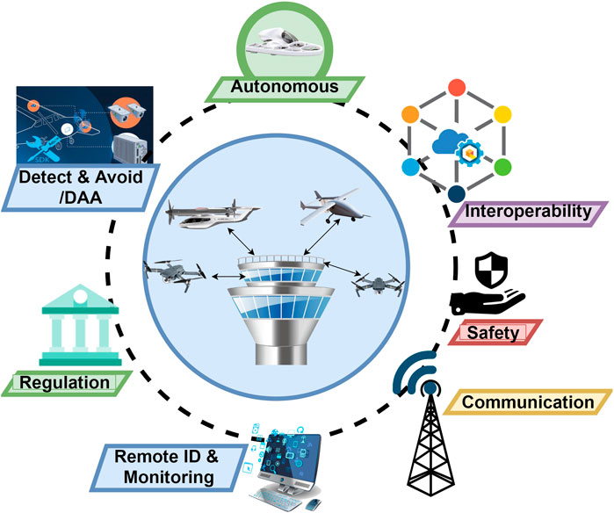

**\*Sensors:\***

- Cameras for video surveillance.

- Inductive loop detectors embedded in road surfaces.

- Radar or lidar sensors for speed detection.

**\*Communication Infrastructure:\***

- Network connectivity for data transmission.

- Wireless or wired communication systems.

**\*Data Processing Units:\***

- Computers or servers to process and analyze collected data.

- Algorithms for traffic pattern recognition and analysis.

**\*Central Control System:\***

- Centralized software for managing and coordinating traffic data.

- User interface for monitoring and control.

**\*Database:\***

- Storage for historical and real-time traffic data.

- Enables trend analysis and reporting.

**\*Traffic Management Software:\***

- Applications for controlling traffic signals and managing congestion.

- Integration with other intelligent transportation systems.

**\*Power Supply:\***

- Reliable power sources for continuous operation.

**\*User Interface:\***

- Display systems for operators to visualize data.

- Control interfaces for manual intervention if needed.

**\*Algorithms and Analytics:\***

- Intelligent algorithms for traffic prediction, optimization, and anomaly detection.

**\*Integration with Other Systems:\***

- Coordination with emergency services, public transportation, or smart city infrastructure.

**\*Maintenance and Diagnostics:\***

- Systems for monitoring the health of components and predicting

* **CONCLUSION:**

In conclusion, a well-designed traffic management system is essential for optimizing traffic flow, reducing congestion, enhancing safety, and improving overall transportation efficiency in urban areas. By integrating technology, real-time data analysis, and adaptive traffic control measures, such systems can contribute to a more sustainable and livable environment. However, their successful implementation requires collaboration between various stakeholders, ongoing monitoring, and the adaptation of strategies to address evolving traffic challenges. Ultimately, a comprehensive traffic management system plays a crucial role in shaping the future of urban mobility and ensuring the well-being of both commuters and the environment.

**GETHUB LINK:**

**https://github.com/kalaivaninagalingam/Kalaivani.git**